Media Advisory
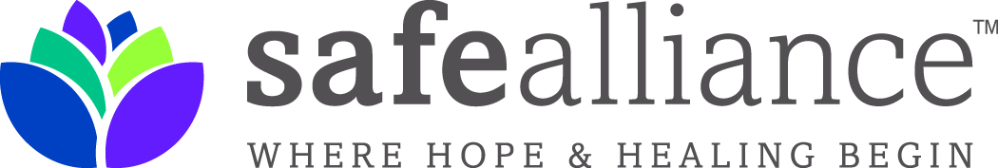

Media Invited to Cover Jingle Bell Bash
Charlotte -- Safe Alliance announces that for the 19th consecutive year, The Jingle Bell Bash (formerly the Jingle Bell Ball) is being held to raise critical funds to benefit Domestic Violence, Child Abuse, Sexual Assault and Mental Health Awareness programs and services.
The Jingle Bell Bash (JBB) takes place Saturday December 7, 2013, 7 PM, at the Wells Fargo Atrium uptown.
The JBB was established in 1994 by the Single Adult Ministry at Myers Park United Methodist Church. The responsibility for organizing this holiday fundraiser has now been turned over to a group of young business professionals who have pledged to preserve the legacy of the event while raising public awareness about the realities of domestic and sexual violence.
We have much to celebrate. It’s been a year now since we changed our name to Safe Alliance, a brand that has been well-received by our friends, clients and benefactors. And come this January, the 80-bed Clyde and Ethel Dickson Domestic Violence Shelter will recognize its first anniversary as a critical community asset providing sanctuary to hundreds of women and children transitioning from violent environments to safety.
Interview opportunities include many individuals working on the front lines in our community to provide hope and healing to victims of domestic violence and sexual assault, including:
- Phil Kline, President & CEO of Safe Alliance
- Karen Parker, Chief Advancement Officer of Safe Alliance
- Joan Randall, Domestic Violence Survivor and JBB Organizing Committee Member
- Brandy Stephens, Director of Clinical Counseling, Safe Alliance
- Kathy Bolster Gauger, Director of Residential Services, Safe Alliance
For additional information: http://www.safealliance.org/jingle-bell-bash/
Media Contact: Bill Coy, Safe Alliance Bill.coy@safealliance.org or 704 367 2707.
Safe Alliance supports victims of domestic and sexual violence, and child abuse and helps people build safe, healthy relationships. We do this through a continuum of shelter, counseling, legal and advocacy services serving over 20,000 people a year in Mecklenburg, Cabarrus, Union and south Iredell counties while reaching 20,000 more through advocacy and education.

