Media Advisory

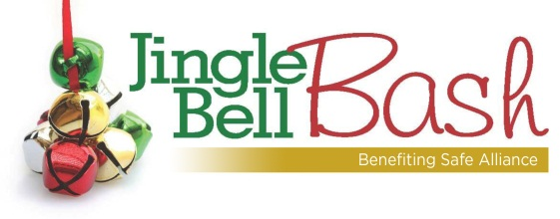

Media Invited to Cover Jingle Bell Bash
Charlotte -- Celebrating 20 years as Charlotte’s can’t-miss holiday party, the Jingle Bell Bash is back again this year to support Safe Alliance and its efforts to assist victims of domestic violence, child abuse and sexual assault.
Jingle Bell Bash will be held 7:30-11 p.m. Saturday, Dec. 6, 2014, in the Wells Fargo Atrium in uptown Charlotte. This holiday tradition will feature a silent auction, live music by the band U-neek Flav’ur, dancing, drinks and hors d’oeuvres. The silent auction is the perfect place to find great holiday gifts, including designer bags and local sports memorabilia, for friends and family.
Not only will attendees be raising funds for Safe Alliance’s important services in our community but they will also be taking a public stand against domestic and sexual violence.
The Jingle Bell Bash will be Phil Kline’s final event as Safe Alliance’s President and CEO. Phil has announced that he will be retiring from the agency at the end of this year. We all thank Phil for his leadership and years of service to Safe Alliance.
We are also very pleased to announce that the Safe Alliance Board of Directors has named Karen Parker to succeed Phil as President & CEO, effective January 1, 2015. Notably, Karen will be the first female to hold the President & CEO position in the organization’s 105 year history.
Interviews are available with Phil Kline and Karen Parker. Click here for more information about the Jingle Bell Bash and to purchase tickets online.
Media contacts:
Leah Galloway, JBB Committee member: leahgalloway@gmail.com or 704-618-3648
Meghan Cooke, JBB Committee member: meghancooke@gmail.com or 336-971-5881
Bill Coy, Safe Alliance: Bill.Coy@safealliance.org or 704-367-2707
Safe Alliance supports victims of domestic and sexual violence and child abuse and helps people build safe, healthy relationships. We do this through a continuum of shelter, counseling, legal and advocacy services serving more than 20,000 people a year in Mecklenburg, Cabarrus, Union and south Iredell counties while reaching 20,000 more through advocacy and education.

