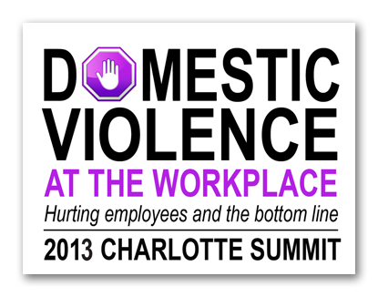
Media Advisory

Members of the news media are invited to attend and cover the Domestic Violence at the Workplace Summit 2013 presented by Verizon Wireless and Safe Alliance.
Who: This Summit is targeted toward leaders in local businesses including HR professionals, security directors, legal counsel and employee assistance professionals.
What: This day-long Summit is designed to offer important “how to” practices for companies seeking to establish domestic violence workplace protocols and processes.
When: The Summit takes place Friday October 11, 2013, beginning at 8:30 AM and running until 4:30 PM.
Where: The Summit is being held at The Employers Association, 3020 West Arrowood Road, Charlotte, 28273.
Why: Domestic Violence has a profound impact on business. Domestic violence has been estimated to cost employers in the US up to $5 billion a year. It is not uncommon for abusers to seek out their partner at work, endangering her, co-workers, customers and others on the scene. More than 70 percent of all businesses have no formal policy addressing domestic violence.
Event Information: Carol Roth, Safe Alliance, 704 367 2799 or carol.roth@safealliance.org

Media information: Margee Herring, Verizon Wireless, 910 233 2466 or margeeherring@gmail.com
Bill Coy, Safe Alliance, 704 367 2707 or Bill.coy@safealliance.org

Please see the attached event flyer for additional details.

