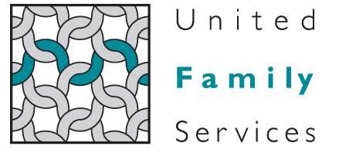
For immediate release

Contact: Kathryn Firmin-Sellers
Lake Norman Region Director, United Family Services
Ksellers@ufsclt.org
(704) 808 4750

Domestic Violence Support Group Being Formed in Lake Norman Community

Cornelius -- The Lake Norman Office of United Family Services announces the creation of a support group for domestic violence victims The group will enable participants to meet regularly, discuss common worries and stresses, and establish a local support network.
The group will meet in a confidential place, at no cost, every other Tuesday evening from 6 to 8 PM. The first group meeting is scheduled for July 10, 2012.
“All women deserve to be in an emotionally stable and physically safe relationship,” said Kathryn Firmin-Sellers, Lake Norman Region Director for United Family Services. “Whether you are in an unsafe or abusive relationship now, or you exited such a relationship already, we invite you to attend these sessions to learn from and gain the support of others who understand the dynamics of abuse. “
Firmin-Sellers says she hopes that attendees will experience empowerment through the support of others who have gone through similar experiences.
Support group meetings will be facilitated by Amy Putnam, United Family Services’ Victim Advocate, and Heather Chavis, Client Care Specialist.
For more information about attending this domestic violence support group, please call (704) 808 4743. Please know that your inquiries will be handled as private and confidential.
United Family Services assists more than 25,000 people annually throughout our geographic footprint that includes Mecklenburg, Cabarrus, South Iredell and Union Counties. We also reach thousands more through our educational and prevention programs as well as institutional advocacy efforts.

-END-

