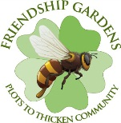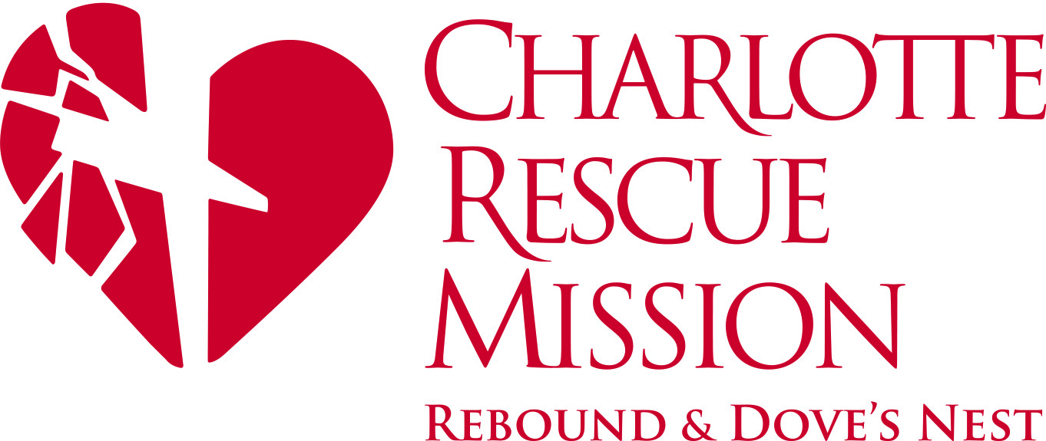

For immediate release

Contact:
Karen Parker, Chief Advancement Officer Safe Alliance
karen.parker@safealliance.org
704-367-2760

DVA and Friendship Gardens Partner on Digging in the Dirt Garden Installations at Local Nonprofit Organizations

Charlotte – DVA Charlotte is celebrating the one-year anniversary of its extraordinary nonpartisan efforts to support the betterment of the Charlotte region by leading a service project supporting the Healthy Children and Families legacy that will greatly benefit women and children experiencing crisis and trauma.
On Sunday October 6th the group will partner with Friendship Gardens on Digging in the Dirt to install two raised bed gardens at both the Safe Alliance Clyde and Ethel Dickson Domestic Violence Shelter and the Charlotte Rescue Mission Dove’s Nest. The installation will begin at 2pm and while the event is not open to the public, media are invited to attend and representatives of each collaborating agency will be available for interviews. The installation will begin at 2845 West Blvd.
Tony Marciano, CEO of the Charlotte Rescue Mission, and Phil Kline, CEO of Safe Alliance, agree, “The installation of the new gardens is another wonderful aspect of our community partnership to assist women and children coming out of crisis. We look forward to having fresh produce to serve at each facility and the opportunity for clients to participate in the management of the gardens. We sincerely appreciate DVA Charlotte and Friendship Gardens for their donation of resources, time and energy to improve the health and lives of the clients we serve. ”

DVA Charlotte was formed in 2012 when 500 women from all walks of life came together with a common desire to make the 2012 Democratic National Convention a success. DVA (Donors, Volunteers and Ambassadors) helped Charlotte shine in the national spotlight, and create a legacy that continues to benefit our community.
Friendship Gardens, a partnership between Friendship Trays and Slow Food Charlotte, is a network of more than 60 gardens across Charlotte. Each garden project teaches gardening skills and grows food for people that need it. We believe everyone should have access to fresh, healthy food. For more info please visit our website www.friendship-gardens.org
The Charlotte Rescue Mission provides a free 90-day Christian residential program for men and women who are addicted to drugs and/or alcohol and are predominantly homeless. For more information, visit www.charlotterescuemission.org or call 704-333-HOPE.

Safe Alliance provides domestic violence, sexual assault, child abuse and trauma services to more than 20,000 people annually throughout their geographic footprint that includes Mecklenburg, Cabarrus, South Iredell and Union Counties. They also reach thousands more through education and prevention programs as well as institutional advocacy efforts. www.safealliance.org.

-END-

