Media Advisory
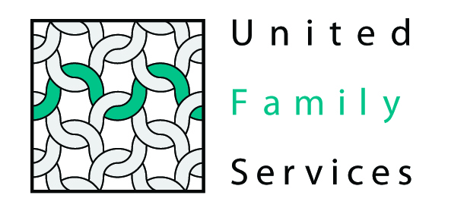

Contacts: Pam Caskey, UFS Union Region Director, 704 290 0150
Bill Coy, UFS Media Relations, 704 367 2707
Kedar Bryan, Community Matters, 704 522 2721

Community Matters: Insurance Partners of Charlotte Donating Quilts to The Tree House
Monroe – The Union County Office of United Family Services announces that Community Matters: Insurance Partners of Charlotte is donating more than 60 hand-made quilts to The Tree House Children’s Advocacy Center.

The United Family Services office in Union County gives hand-made quilts to the children who are served at The Tree House Child Advocacy Center. Each child who is referred to the Tree House due to suspected sexual or physical abuse is given a hand-made blanket with which to cover themselves during the medical examination and forensic interview. Afterwards, the blanket is theirs to keep. The Tree House staff explains to the children and their families the blankets are made by caring people in the community who want to help them. “These hand-made blankets mean a great deal to the children who receive them and provide some much-needed comfort and warmth during a very difficult time” says Pam Caskey, Region Director.

Community Matters leaders and the ladies that organized the quilting effort will deliver the quilts to our Union County Office on August 9, 2012 at 9 AM. News media members are welcome to attend.

Community Matters is a new nonprofit organization comprised by more than 45 firms in the insurance industry dedicated to making a difference in the community by providing major financial support to worthy charitable agencies. Community Matters selected United Family Services as its first charity partner.

Here is the background:
Patti Faber and Cheryl Kitchen of insurance company Arrowpoint Capital (A member of Community Matters) were attending a "Lunch & Learn" session where they heard United Family Services Board Chairman John Tighe talk about the work of The Tree House Children's Advocacy Center - that provides services and counseling to child abuse victims and their families. So they decided to get involved. Active quilters, they spread the word through their network of friends and family in North and South Carolina.
The result: more than 60 quilts that will be given to child victims of sexual assault and neglect as they are examined by doctors at our Children’s Advocacy Center. The Tree House offers a child/teen friendly environment for abused children and their families to receive comprehensive services and counseling as they recover and heal from trauma.
The quilts are therapeutic and help to provide a sense of comfort and security for the children.
We welcome you to attend this photo opportunity at our Union County office. The quilters, members of Community Matters and representatives from the Tree House Children’s Advocacy Center will be available to answer your questions.

United Family Services assists more than 25,000 people annually throughout our geographic footprint that includes Union, South Iredell, Cabarrus and Mecklenburg counties. We also reach thousands more through our educational and prevention programs as well as institutional advocacy efforts.

-End-

